Evolution by Natural Selection

Describe what is happening in figures 1-3. Is the population of mice different in figure 3 than in figure 1? Explain why.
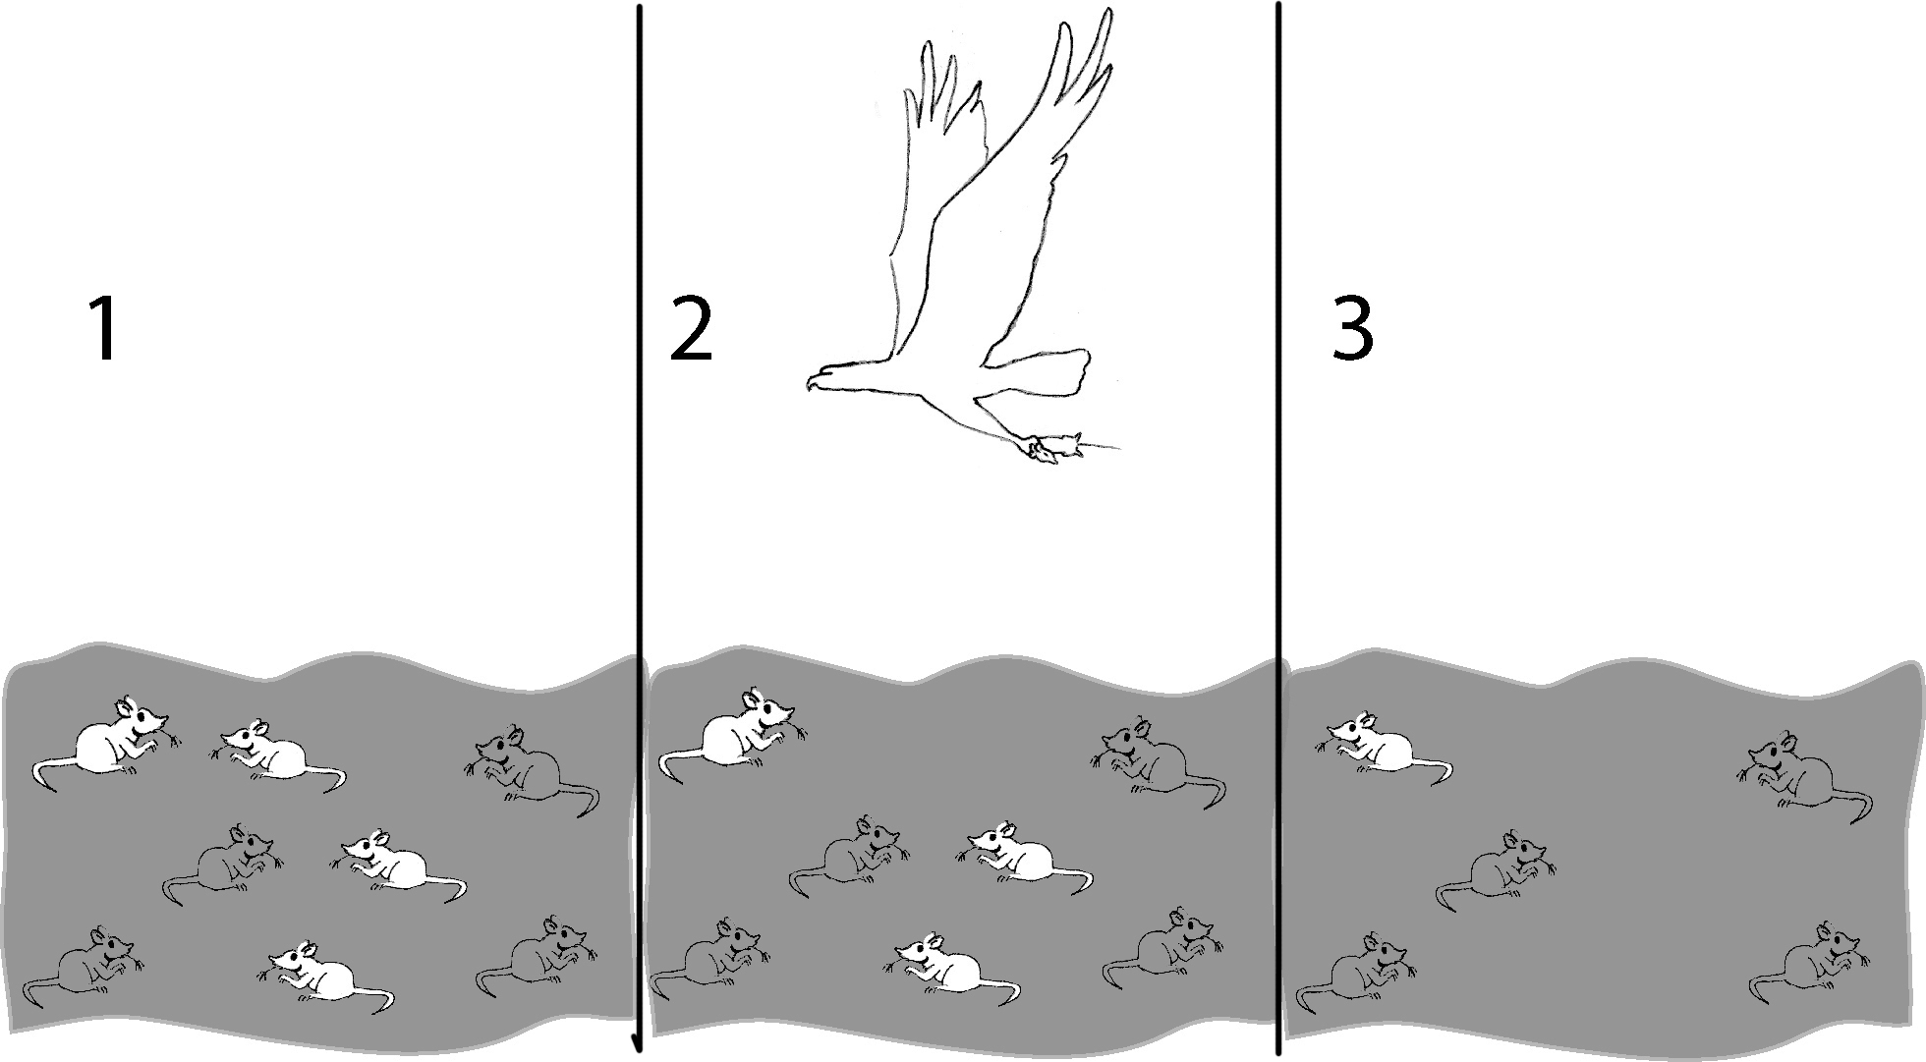

Living things that are well adapted to their environment survive and reproduce. Those that are not well adapted don’t survive and reproduce. An adaptation is any characteristic that increases fitness, which is defined as the ability to survive and reproduce. What characteristic of the mice is an adaptation that increased their fitness?

The table below gives descriptions of four female mice that live in a beach area which is mostly tan sand with scattered plants. According to the definition given for fitness, which mouse would biologists consider the fittest? Explain why this mouse would be the fittest.

Color of fur | Black | Tan | Tan and Black | Cream
Age at death | 2 months | 8 months | 4 months | 2 months
# pups produced by each female | 0 | 11 | 3 | 0
Running speed | 8 cm/sec. | 6 cm/sec. | 7 cm/sec. | 5 cm/sec.

If a mouse's fur color is generally similar to its mother’s color, what color fur would be most common among the pups?

A characteristic which is influenced by genes and passed from parents to offspring is called heritable. Over many generations heritable adaptive characteristics become more common in a population. This process is called evolution by natural selection. Evolution by natural selection takes place over many, many generations.

Evolution by natural selection leads to adaptation within a population. The term evolution by natural selection does not refer to individuals changing, only to changes in the frequency of adaptive characteristics in the population as a whole. For example, for the mice that lived in the beach area with tan sand, none of the mice had a change in the color of their fur; however, due to natural selection, tan fur was more common for the pups than for the mother mice.

In summary, a heritable characteristic that helps an animal or plant to have more offspring which survive to reproduce will tend to become more common in a population as a result of evolution by natural selection.

Questions

1. Explain why a characteristic which helps an animal to live longer will generally tend to become more common in the population as a result of evolution by natural selection.

2. Not all characteristics which contribute to longer life become more common in the population. Some characteristics contribute to long life, but not more offspring. For example, a female cat which is sterile(not able to reproduce) and cannot have any offspring may live longer because she will not experience the biological stresses of repeated pregnancies. Explain why a characteristic like this which contributes to a long life, but with few or no offspring, would not become more common as a result of evolution by natural selection.

The following example will illustrate that evolution by natural selection can not occur if the variation in a characteristic is not heritable. This example also illustrates a more complete definition of fitness, which is the ability to survive and produce offspring who can also survive and reproduce. According to this definition of fitness, which of the four male lions described below would biologists consider the “fittest”?

Name | George | Dwayne | Spot | Tyrone
Age at death | 13 years | 16 years | 12 years | 10 years
# cubs fathered | 19 | 25 | 20 | 20
# cubs surviving to adulthood | 15 | 14 | 14 | 19
Size | 10 feet | 8.5 feet | 9 feet | 9 feet

Explain why Dwayne is not the fittest even though he lived the longest and fathered the most cubs.

Which of the following scenarios would result in natural selection?
a. Tyrone has heritable characteristics that increase resistance to infections and help cubs survive to adulthood.
b. Tyrone happens to live near a farmer who puts antibiotics in meat which he leaves out for Tyrone's lion cubs.

Explain why natural selection does not operate on characteristics which affect fitness but are not heritable.

8. "Survival of the fittest" is a common expression. What do you think most people mean by this expression? How would you explain this expression to help someone understand how natural selection actually functions?

8. Below is a series of pictures representing changes in a population of cacti. Pictures 1 and 2 show what happened when a deer came to eat, picture 3 shows the cacti a few weeks later (notice the flowers on the right-hand cactus), and picture 4 shows the situation a few months later.

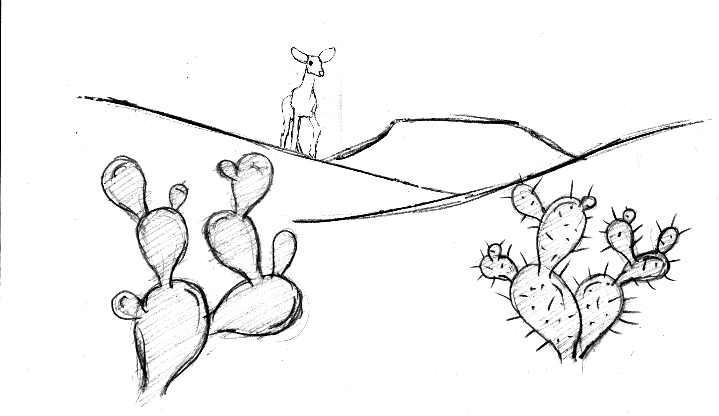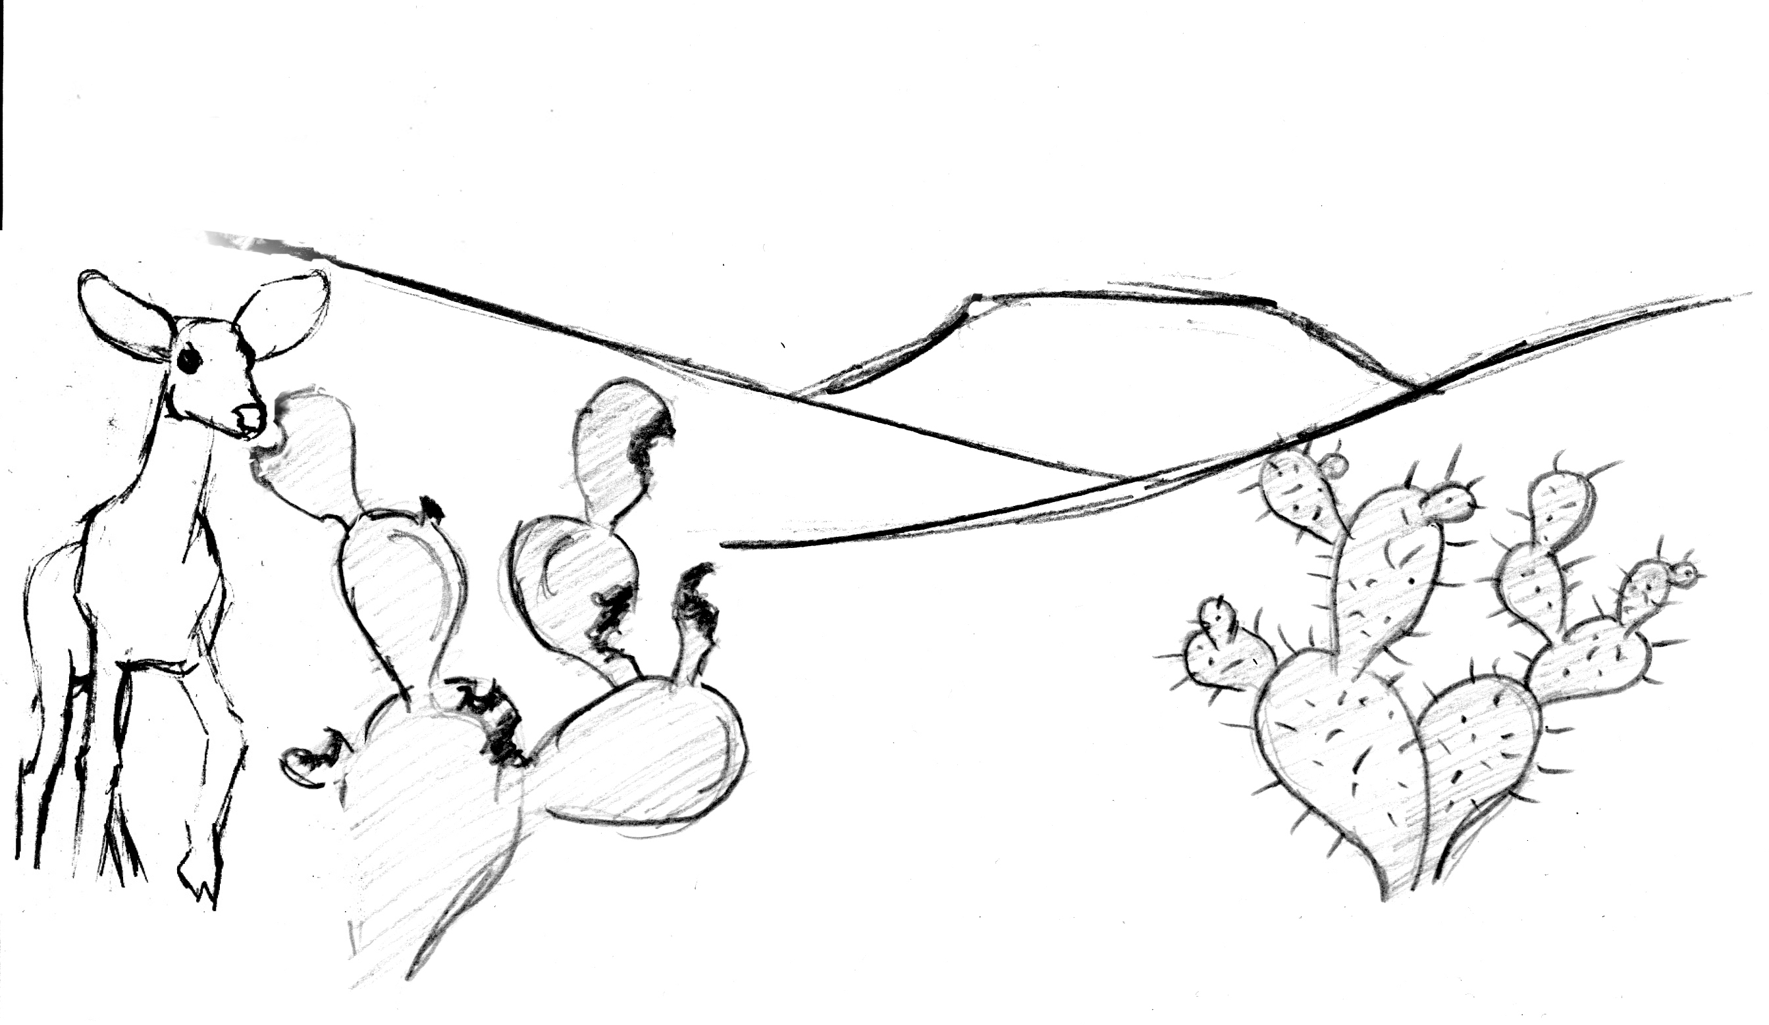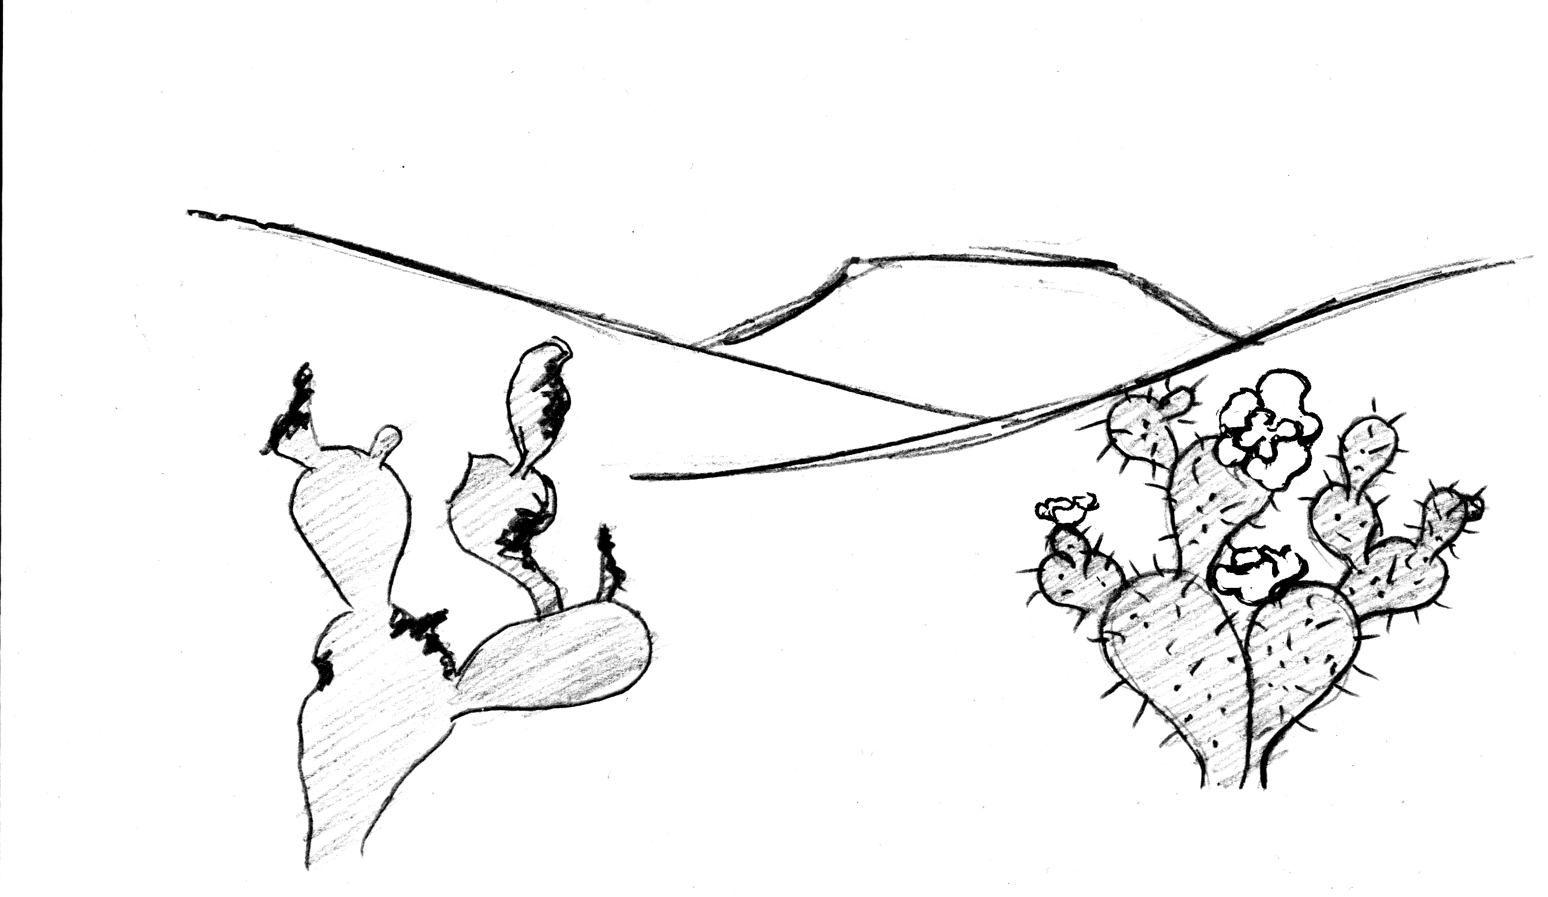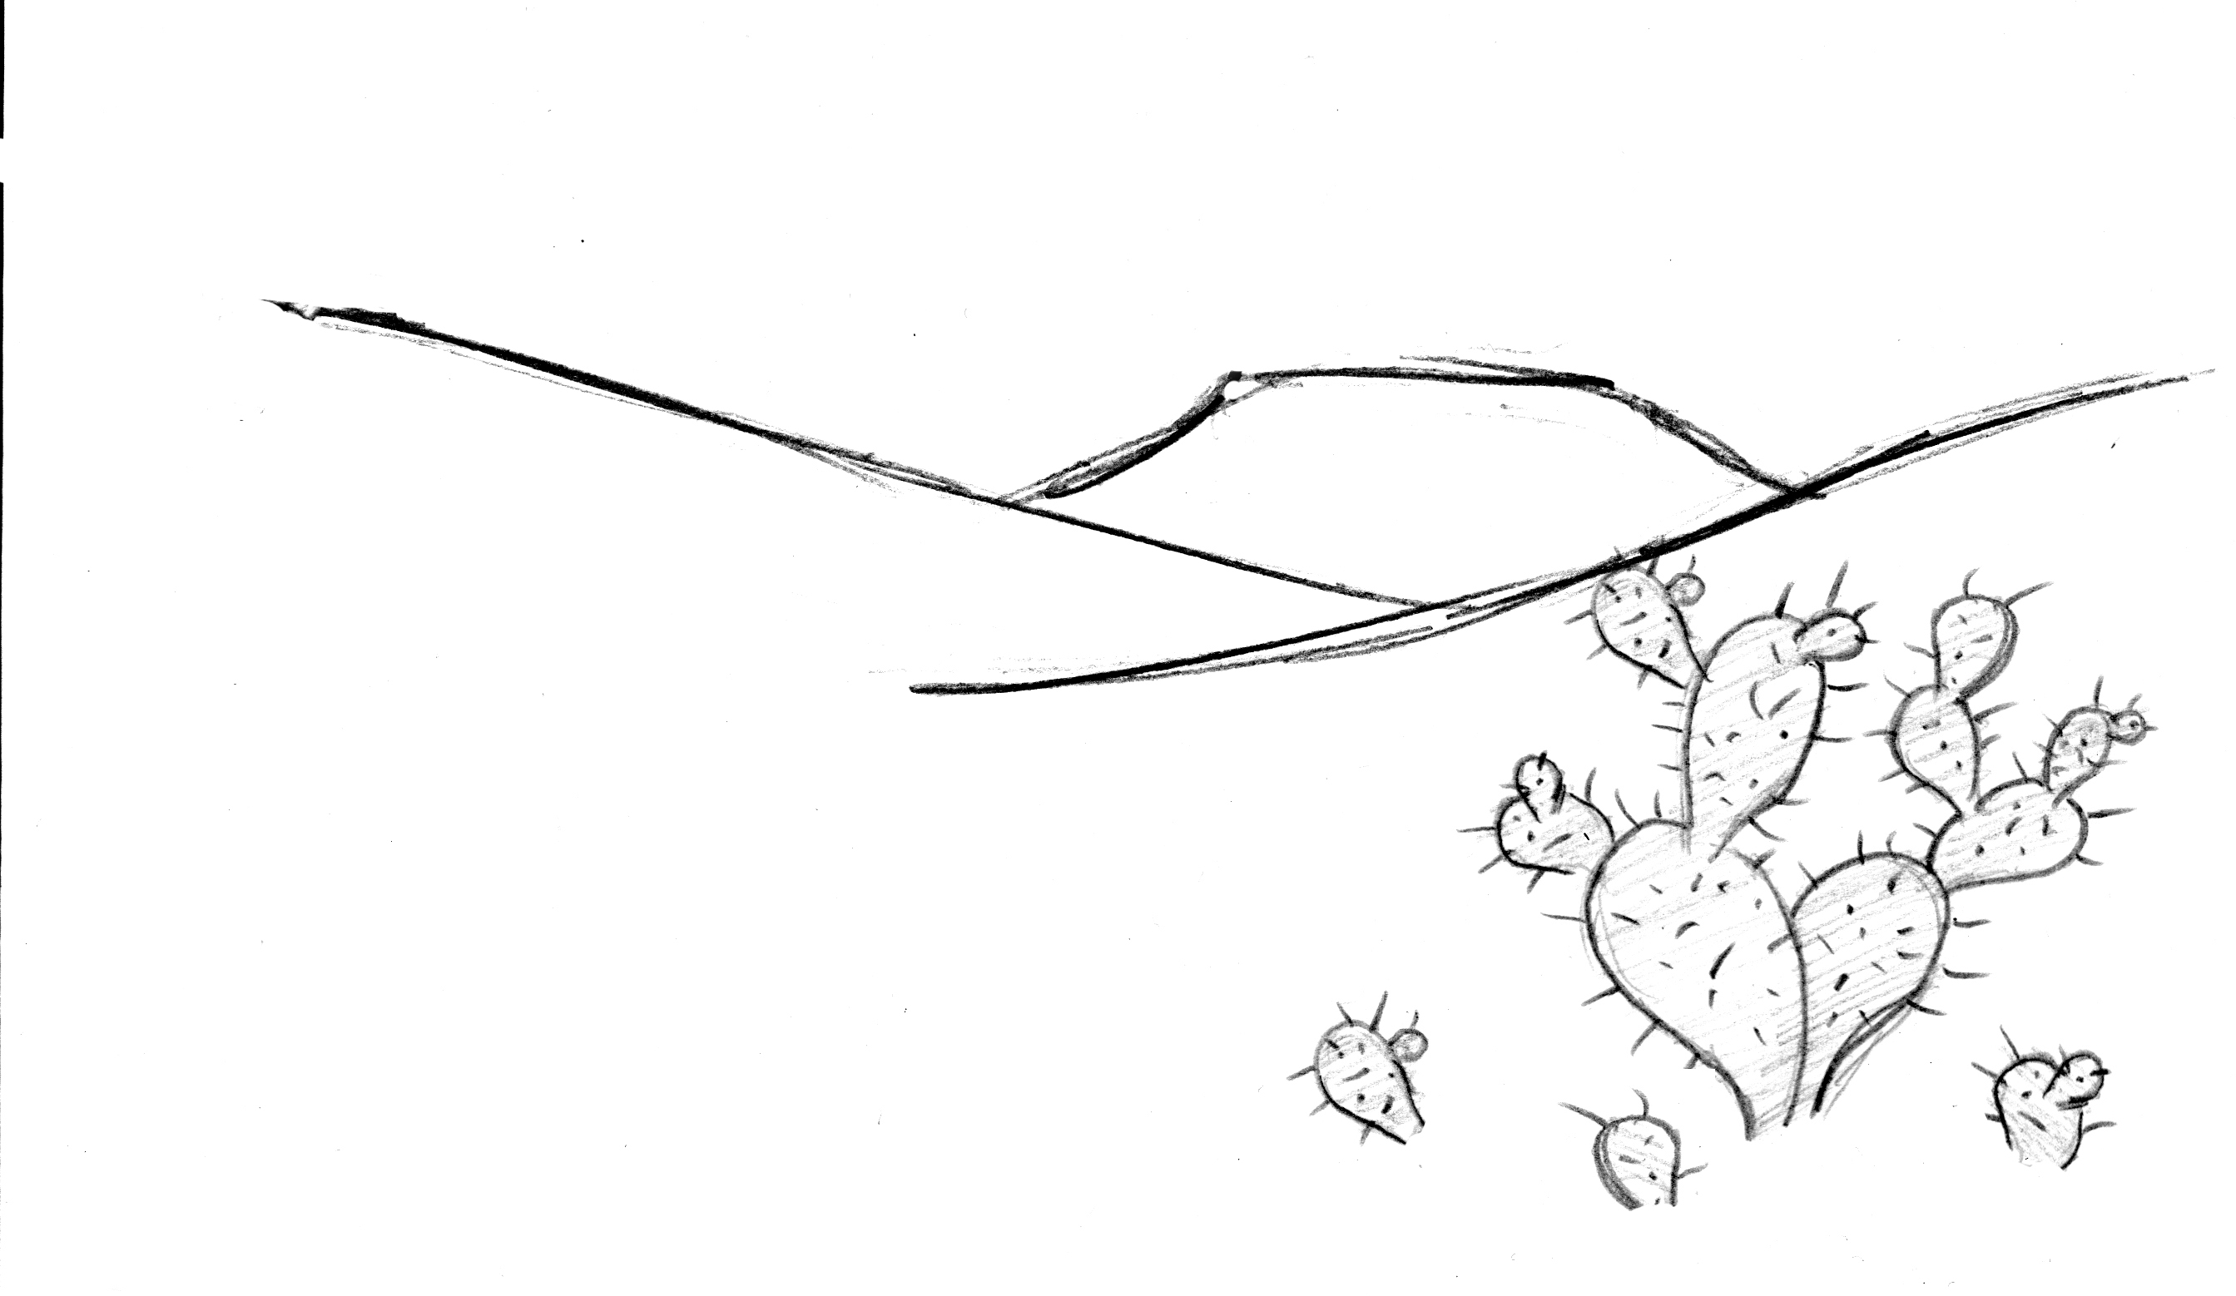
1
2
3
4

Recall that the three conditions listed below are necessary for natural selection to take place.

- Variation in characteristics within the population: In picture 1, what is the main difference between the cactus on the left and the cactus on the right?

- Differences in survival and reproduction, fitness: Why would a deer be more likely to eat the cactus on the left than the cactus on the right?

What effect does the deer's behavior have on the survival and reproduction of these two types of cactus?

- Heritability of characteristics from parent to offspring: The difference between the cacti is a heritable characteristic (see picture 4).

Do you think that evolution by natural selection is occurring in this cactus population? Explain why or why not.

