Wonderful World of Invertebrates WebQuest
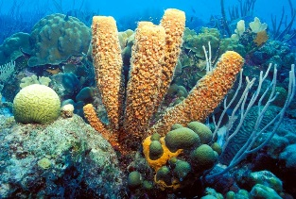
Phylum Porifera- Sponges
- How many species of sponges are found in the world? (tell about where they live)
- Explain what cellular-level organization means? Click here to see how sponges are built.
- What are choanocytes?
Click here for more information
- Describe the body plan of a sponge.
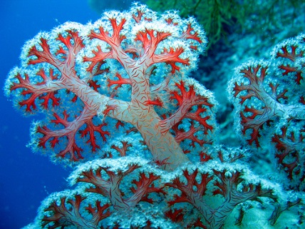
Cnidarians: Jellyfish, coral, hydra & sea anemones
- How many openings to the Cnidarian's body? Name them.
- Describe the function of nematocysts.
- List two reasons why Cnidarians are considered important.
- Tell how medusa and polyps are different from one another.
- Do Cnidarian’s hunt their prey? What strategy do they use?
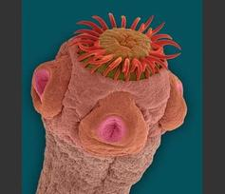
Platyhelminthes: The flatworms
- What percent of flatworms are parasitic?
- What is a hermaphrodite?
- What is a tapeworm and how does it get nutrition?
- How long can tapeworms be?
- How do you get a pork tapeworm?
Mollusks- soft bodied invertebrates
Click the link- choose Tropical Ocean Animals- Mollusks
- How many species of mollusks are there?
- Describe the three body regions of a mollusk.
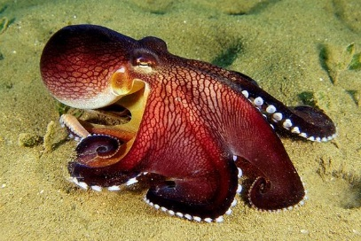
SCOLL DOWN
- Explain how pearls are made.
- What is the difference between a squid and an octopus?
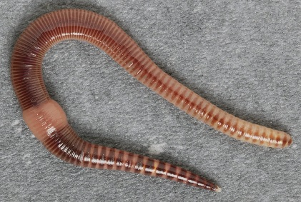
Annelida – segmented worms
- What is a unique characteristic of Annelids?
- What does Polychaete mean?
- How many species of Annelids are there today?

Echinoderms: Spiny skinned invertebrates
- Give 3 examples of echinoderms.
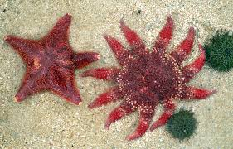
- What are the characteristics of Echinoderms?
- What is the function of tube feet?
- Explain the unusual relationship between the sea cucumbers called Holothurians and pearlfish.
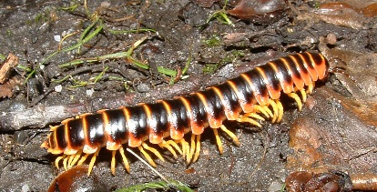
Arthropods: animals with exoskeletons & jointed appendages
Click on introducing the arthropods – Go through the presentation and answer the questions. You will have to click on the NEXT arrow to move onto the next page. Read carefully!
Don’t miss any questions!!
- Explain one reason that arthropods are such a wildly successful group of animals.
- In fact, more than _______ of all described animal species are arthropods.
- About a ___________ ___________ insects are alive at any time. That's about ____________ million insects for each person on Earth!
- Tiny crustaceans called ___________, less than a centimeter long, are the most ___________ animals in the ocean. There are so many of them, that they outweigh all the ___________ on Earth!
- Give 2 examples of distribution; include name and where it lives.
- Give 2 examples of ecological niches; include name and what its job is.
- What are 4 reasons why arthropods are so successful?
- Most arthropods display five characteristics. We can use these to determine which animals are arthropods. These arthropod characteristics include:
- Which of these animals have bilateral symmetry?
- Which of these animals are segmented?
- Which of these animals grows its own hard exoskeleton?
- Which of these animals have jointed legs?
- Which of these animals have many pairs of limbs?
- Based on what you have learned, name three arthropods.

